**Christopher Straka**

**Student ID:** 011551615

**Business Vision:**

**Objective:** Enhance user engagement and satisfaction on our streaming platform through a personalized movie recommendation system.

**Vision Statement:** To become a leading streaming service known for intuitive, user-centric content discovery and recommendation capabilities. To drive increased user retention and growth.

**Datasets:** The data was already cleaned by the creator of the Kaggle dataset. I changed the variables to snake case to fit conventions with python, but nothing else was done to alter the dataset. Data is in model/data.Datasets were collected from <https://www.kaggle.com/datasets/rounakbanik/the-movies-dataset>

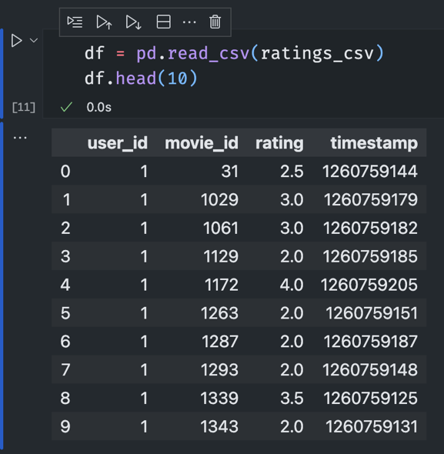

**Data Analysis Code And Storytelling:**  
  
Please see the model/model.ipynb notebook for data analysis code and storytelling.

**Hypothesis Evaluation:** I accept the hypothesis because having recommendations make the service much more engaging. When inspecting user 5’s ratings and recommendations, the result is a very natural fit for that person.

